Here are some finding when I tried to run your code. Maybe the file and data name regulation will be much easier and clear if you make some changes to that.

1. It’s clear that you separate the data clear process in each individual files,
2. Add chunk may be helpful to regulate the layout of the whole process.
3. Maybe put output into one folder and create a new overall script which you will be working on will make it easy to understand.

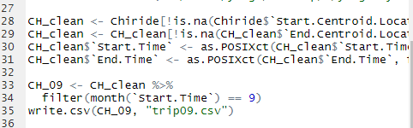In the following part, for example, combine those CH_clean steps into one chunk will make it easier to understant the organization.

1. Try to add notation and level of titles, which will make long script easier to be separate into several key parts.
2. We share identical topics together, while I’m trying to analysi the mobility pattern of new york taxi ridership, maybe we can discuss more when facing problems.
3. I’m glad to see the multiple dataset you got access from OSM and other features you added in, I plan to learn from you for my feature engineering part.
4. Wish you have a produce final month😊